**HanRongDa HRD-747**

**Operation Guidelines for Full-Band Radio Model:**

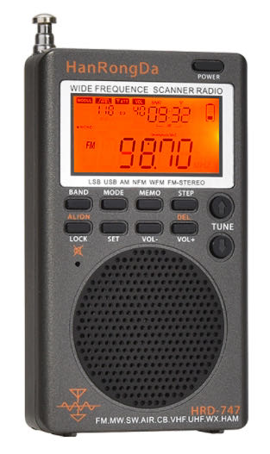

**FM/MW/SW/AIR/CB/VHF (UHF) /UBD/WX/**

**HAM WIDE FREQUENCE SCANNER Radio**

**Contents**

|  |  |
| --- | --- |
| Packing List………………………………………………………………………………. | 3 |
| Overview of HRD-747 wide frequency radio…………………………….. | 4 |
| Description of product buttons………………………………………………... | 5 |
| Description of display symbols on the display screen……………….. | 7 |
| Operation cautions………………………………………………………………….. | 9 |
| Instructions for button functions and operations……………………… | 10 |
| About orange backlight……………………………………………………………. | 32 |
| Use of Antennas………………………………………………………………………. | 32 |
| Main technical parameters.……………………………………………………… | 33 |
| Cautions ……………………………………………………….…………………………. | 34 |

Thank you for purchasing the Digital Reconciliation Full-band Radio (Model: HRD-747) from HonRongDa. It is an entry-level toy product for radio lovers, and also the auxiliary product for cross-country activity lovers (VHF/UHF Station reception). It can provide flight information for those who often take planes. Please read this manual before you use it and keep it well for referencing in the future.

**Packing List**

|  |  |
| --- | --- |
| **Name** | **Quantity** |
| HRD-747radio | 1 |
| IN-EAR headset | 1 |
| BL5C lithium battery 1000mAh 3.7V | 1 |
| USB TYPE-C cable | 1 |
| Product manual | 1 |
| Arm hanging rope | 1 |
| Storage bag | 1 |

**Overview of HRD-747 Wide Frequency Radio**

This is a Wide Frequency radio with digital tuning: It can receive FM (frequency modulation)/MW (medium wave)/SW(short wave) (short-wave single-side with modulation mode)/SSB (Upper Sideband)/LSB (Lower sideband)/AIR (Aircraft band)/CB (City band) /VHF(very-high frequency band)/UHF (Ultra high frequency band)/UBD(us-er-defined band)/WX(North American National Weather Band)

1. The product is compact and easy to carry.
2. Modern DSP digital demodulation technology is used to the full band, which improves the receiving sensitivity, selectivity and anti-mirror interference ability.
3. FM receiving range is 64MHz-108MHz. It is suitable for FM broadcast reception and global FM radio reception.
4. The single slideband SSB and the lower slideband LSB of the shortwave unilateral-band can receive signal independently.
5. Many kinds of station selection methods: Automatic search storage station (ATS), manual search pre-stored station (VM) and manual search for radio stations (VF).
6. It can display the radio address number; browse radio station frequency automatically and browse the frequency of pre-stored radio stations automatically; high speed scanning; shuttle tuning, shuttle stepping setting (support 10Hz), adjustable design of shuttle stepping digit (for select frequency quickly)
7. SET menu has the following advanced settings:

A. Adjustable antenna input attenuation controller circuit. ATT

B. Adjustable circuits of various bandwidth. BW

C. Adjustable silencing 9 level. SQ

D. De-emphasis selection in FM band mode DE

E. The frequency of FM and AM bands can be set in many countries.

1. Many step values of each wave band can be adjusted STEP
2. Celsius temperature/Fahrenheit can be displayed
3. Not only the automatic sleep time and automatic boot time can be set, but also the lock and mute state can be set.
4. Receiving state can display the noise limit ratio and the receiver sensitivity reference value.
5. The radio has a large memory space, so it can store up to 1000 radio frequencies. The product supports manual deletion of memory stations.
6. External antenna 3.5mm input can be supported.
7. External speaker and 3.5mm headphone output can be used.
8. Built-in loudspeaker and within USB TYPE-C charging jack.
9. Removable BL5C lithium battery of 1000mAh and long battery life can be used.
10. The backlight of the product is a warm orange light which can be used in the night/dark areas.

**Description of product buttons**

At the top of the product:

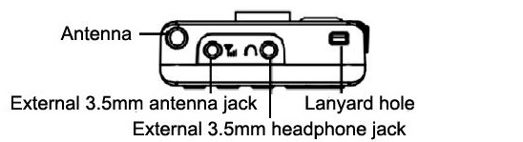

Front view:

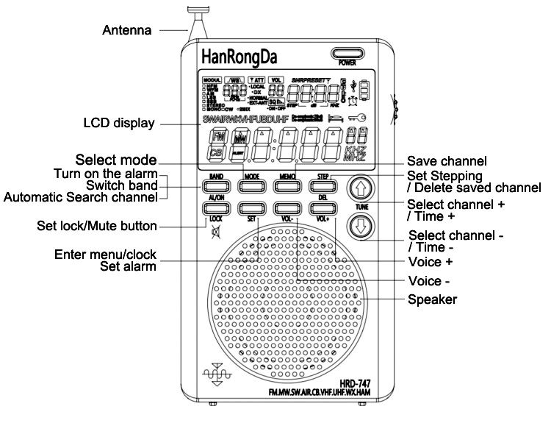

Right view and back view of the product:

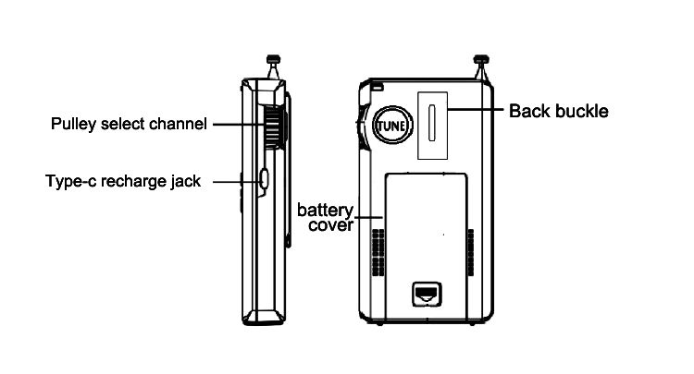

**Description of display symbols on the display screen**

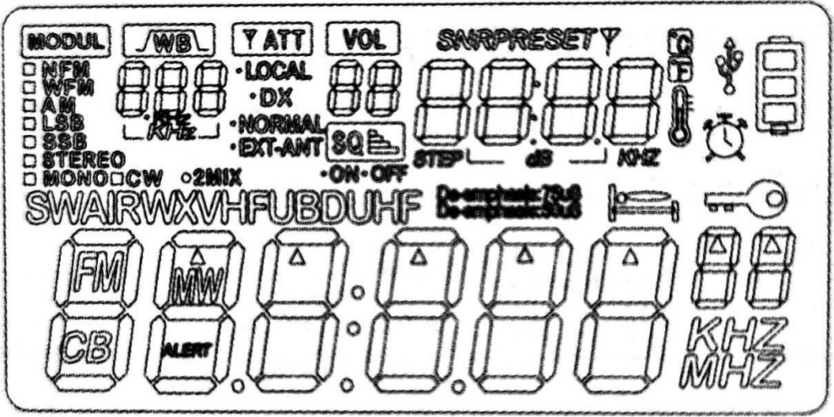

MODUL: Modulation mode switching display

NFM: Narrowband FM mode

WFM: Broadband FM mode

AM: AM system

LSB: The lower sideband of a single sideband

USB: The upper band of a single sideband

STEREO: Stereo reception state in FM mode

MONO: FM mono receiving status

2MIX: Secondary frequency conversion display

BW: Bandwidth selection of each band

ATT: Adjustable gain attenuation controller circuit selection: LOCAL,DX,NORMAL

VOL: Volume adjustment (from 00 to 40)

SQ ON: Under silent receiving state

SQ OFF: Under the SQ off state

SNR: Signal Noise Ratio

PRESET: Pre-stored stations

STEP: Step value settings display

 : Flying-shuttle step mark

dB: SNR and reception sensitivity unit

°C: Temperature Celsius

°F: Fahrenheit

 : Thermometer

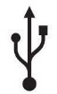 : Charging indication symbol

: Battery power display symbol

: Alarm setting display symbol

: Symbol to set sleep and shutoff time

: Locked state

FM: Frequency modulation receiving mode

CB: City band receiving mode

MW: Medium wave receiving mode

SW: Short wave receiving mode

AIR: Aircraft band receiving mode

WX: Weather band receiving mode

VHF: Very High Frequency mode

UHF: Ultra-high frequency mode

UBD: Customized input frequency point mode

ALERT: Alarm display symbol

De-emphasis: 50uS / De-emphasis: 75Us: display

EXT-ANT: Indicator of external antenna

**Operation Cautions**

Before using this radio, please ensure that you can follow the following basic safety tips so that the products can be used safely and reliably.

* Read and understand all safety guidelines and usage information.
* The original lithium battery is recommended.
* It is recommended to use a charging device with the output voltage of DC5V/1A-3A to avoid damage to the lithium battery or the device.
* When the lithium battery is not used for a long time, please take it out and keep it separately. Charge it once a month.
* Do not expose the product to rain, moisture, drips or splashes of any liquid.
* Do not keep the product near high temperature and heat source; do not bake or blow it at high temperature.
* Do not expose the product to direct sunlight for a long time.
* Do not allow the product to fall or be hit. Do not apply heavy pressure on it.
* Note: TV sets, computers, generators, electric motors and other electrical equipment as well as other signal generators may also interfere with signals received by the radio. Please keep a certain distance from the above equipment when you use them.
* The antenna of the product is a seven-section telescopic antenna (the exposed part is 56CM). It is relatively long. Please do not bend it and break it.

**Instructions for button functions and operations**

1. **Install the cell**

Open the battery cover and insert BL5C lithium battery correctly according to its positive and negative polarity and then cover the battery cover. After installing the battery, press any key to start the backlight and display the time. After installing the battery, the radio backlight will be turn on and show the time status.

**2. [POWER] Power-ON/OFF/ Sleep time settings**

**2.1 Power ON/OFF function:**

Time state, press lightly POWER button, radio on. When the radio on, long press the POWER button, radio off.

**2.2 Sleep time settings:**

Time state: long press [POWER] for 2 seconds to display "90" minutes and start the sleep function. then short press [POWER], you can choose the sleep time for 90-80-70-60-50-40-30-20-10 minutes. After the sleep time is set, LCD display will show 

Note: the radio will turn off automatically to show

**2.3 Enable SNR&RSSI function and time switch display**

Radio working state: short press [POWER] to start SNR&RSSI function and time switch display. This is a reference value for SNR and receiving

sensitivity: 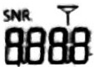

Time status: 

**3. [Lock] Set the LOCK, unlock/mute operation**

**3.1 Setting locking and unlocking operations:**

In the radio ON/OFF state, long press LOCK 2 seconds, it will display . Then, all the buttons could not be operated. Long press [**LOCK**] again for 2 seconds, when the  symbol disappear, all buttons can be operated.

**3.2 Set the mute mode:**

Radio on working state, short press [**LOCK**]. "VOL 00" symbol is flashing, radio will enter the mute mode. In the mute state, short press [**LOCK**]. Restore the current sound level, at this time mute function is disabled.

**4. External DC5V input power supply operation**

When the battery symbol shows a space, please connect the charging cable of Type-C (factory standard accessories TYPE-C USB cable) to the DC5V power supply to power the radio input. During the charging process, the battery symbol " "will keep flashing. After full charge, the battery symbol stops flashing and displays full.

**5. 3,5mm headphone jack operation**

Listening radio programs, you can use the radio itself loudspeaker. And also a 3.5mm plug earphone. (Use a 3.5mm earphone to avoid disturbing others).

**6. Volume [VOL+/-]**

Short press "**[VOL+]** and **[VOL-]",** the volume will increase or decrease by 1 step according to the minimum step. Long press "**[VOL+]** and **[VOL-]**" to increase and decrease the volume rapidly. The adjustable volume range is 00-40 level.

**7. [MEMO]: manually storage/ pick up station operation**

**7.1 Manual storage operation method:**

Adjust to the target frequency point by [**TUN"⇑ . ⇓"**]

Long press [MEMO] for 2 seconds, the PRESET & "**PX X X**"symbol will flash at the same time. PRESET is the preset station prompt, "**P X X X**" is storage station address prompt)

Short press [MEMO], or press [**TUN"⇑ . ⇓"**] also, to select the frequency address.

Short press [MEMO], LCD will display "**S X X X**" about 2 seconds, indicating that the target frequency point has been saved to the target memory number. Note: Each band can store 100 memory stations.

**7.2 Methods to pick up stations:**

-You can either save station by the

**7.2.1 method or long press the BAND to search the station automatically.**

Short press [**MEMO**], LCD will display "**PRESET**" and "**P X X X**".

Short press [**TUN"⇑ . ⇓"**] to get the frequency point of the address number of the target station, then you can get the broadcast radio signal.

Note: If no operating within 3 seconds, it will exit selection operation.

**7.2.2 Methods to pick up stations:**

You can either save station by the 7.1 method or long press the BAND to search the station automatically.

Short press [**MEMO**], LCD will display "**PRESET**" and "**P X X X** ".

Short press [**TUN"⇑ . ⇓"**] to get the frequency point of the address number of the target station, then you can get the broadcast radio signal .

Note: If no operating within 3 seconds, it will exit selection operation.

**8. [TUN"⇑ . ⇓"]: Time setting /select station button**

**8.1 Operation for time settings:**

Time display status: long press [**SET**] for 2 seconds, the hour number will flash; short press [**TUN"⇑ . ⇓"**] to SET the current hour. Tap [**SET**] button, the minute number will flash. Short press [**TUN"⇑ . ⇓"**] to SET the current minute. Note: The hourly system of this machine is 24 hours.

**8.2 Operation for alarm clock settings (automatic boot):**

Setting the current time by 8.1 method.

Tap [**BAND**], the alarm clock symbol  will display.

Tap [**BAND**] again, the alarm clock symbol will disappear, alarm clock time has been canceled.

Long press [**SET**] for 2 seconds,

Alarm hour number "**X X**" will flash. Short press [**TUN"⇑ . ⇓"**] to set the hour. Tap [**SET**], alarm minute number "**X X**" will flash. Short press [**TUN"⇑ . ⇓"**] to set the minute.

**8.3 Operation of Station selection:**

Under the power-on state: If radio have been storage station before, short press [**MEMO**] to select station. LCD will have "**PRESET**"and"**P X X X**"symbols. If need cancel the station selection operation, just short press [**MEMO**] again. "**PRESET**"and"**P X X X**"symbols disappear.

If you want to increase or decrease the radio station, just need to press [**TUN"⇑ . ⇓"**] button.

Long press [**TUN"⇑ . ⇓"**], radio will enter the searching stations function automatically. When signal were found, it will stop searching to play the searched frequency points.

**9. [BAND]: band switch/automatic search and storage/ alarm clock on/off operation**

**9.1 Band Switch:**

In startup state, press [**BAND**] to switch FM/MW (AM)/ SW/ AIR/ CB/ VHF (U H F)/ U BD/WX BAND

**9.2 Automatic station search and storage:**

Long press [**BAND**] to start the automatic scanning and station storage function.

The machine will search from the lowest frequency point to the highest frequency point in the current receiving band. -The radio will automatically save the signal station to the radio memory station number.

After completing a fully automatic search, the radio will play the first station with the first station number.

During the automatic scanning, PRESET character and P X X X station storage address number will flash all the time. The frequency point will change incrementally in the process.

Note: During the automatic scanning: press {**BAND**] or any other key will stop searching station function. -During automatic station search and storage, previous frequency points memorized will be updated.

**9.3 Time state:**

Short press the alarm clock to open/ close the time state (specific operations are described in 8.2 Operation Introduction)

**10. Operations for Step/Delete [STEP]**

**10.1 STEP operation:**

In the power-on state, press [**STEP**] to set the STEP value

The following step options are available in all frequencies

1. FM stepping: 50.0KHZ,10.0KHZ,100.0KHZ.
2. AM frequency: 522-1710KHZ, stepping: 9.0KHZ, 3.0KHZ,
3. AM frequency: 520-1710KHZ, stepping: 10.0KHZ, 5.0KHZ.
4. SW stepping: 5.0KHZ, 1.00KHZ, 0.10KHZ, 0.02KHZ, 0.01KHZ.
5. AIR stepping: 25.0KHZ, 12.5KHZ, 8.3KHZ
6. CB stepping: 5.00KHZ, 1.00KHZ, 0.10KHZ, 0.02KHZ, 0.01KHZ
7. VHF/UHF&UBD step: 25.0KHZ, 12.5KHZ, 7.5KHZ, 5.0KHZ, 1.0KHZ

Once the step value is selected, the system will default to the last selected step value. Press [**TUN"⇑ . ⇓"**] to confirm the last selected step value.

**10.2 Delete station**

In startup state, after manual station storage is done according to 7.1 or automatic station search and storage operation according to 9.2.

Tap [**MEMO**] and "**P X X X** " the number of that storage station will flash; short press [**TUN"⇑ . ⇓"**] to pick up the station which you want to delete. Next just long press [**STEP**] for two seconds. “**DEL & E X X X**" flashes. Then, short press [STEP] to delete the station.

Within 5 seconds, press [STEP] to delete the next pre-set station.

If no operation within 5 seconds, PRESET "**P X X X**” flash, radio exit the operation of deleting function.

**11. Operation for menu/clock settings**

**11.1 Set time operation:**

In the shutdown state, long press [**SET**] for two seconds and then short press [**SET**] and short press "**⇑ . ⇓**" to start the clock setting (refer to details in 8.1).

**11.2 Set menu operation:**

Under the power-on state, start functions of the main menu (refer to Operation Introduction 14 for details)

**11.3 Set Alert alarm:**

In WX band, long press [**SET**] to activate ALERT alarm and the "**SCAN**" symbol flashes. Long press [**SET**] again to exit the Alert function. Note: **SCAN** indicates that WX is in the state of silent detection of NOAA Alert state. If there is an Alert signal, sound or alarm will be given out.

**12. Rotary [flying shuttle] button**

Power-on state: Rotate the flying shuttle to adjust frequency display bit values. When values are adjusted, the corresponding "" flashes. Short press [STEP] to select the needed STEP value. Rotate the flying shuttle to quickly select the desired frequency points.

**13. Mode selection [MODE]**

**13.1 Menu and sub-menu:**

In power-on state, press [**SET**] to start the main menu, short press [**MODE**] to select the corresponding sub-menu functions.

**13.2 Meter band function:**

In short wave (SW) & Very-high frequency (VHF) & Aircraft (AIR) band, non-menu mode; short press [**MODE**] key to switch meter band functions.

**13.2.1 Meter band function on SW:**

In the short-wave (SW) receiving state, short press [**MODE**] to switch the meter band, and the frequency points are:

3.20000MHZ, 3.75000MHZ, 3.90000MHZ, 4.75000MHZ, 5.73000MHZ, 7.10000MHZ, 9.25000MHZ, 11.50000MHZ, 13.57000MHZ, 15.03000MHZ, 13.57000MHZ, 15.03000MHZ, 17.48000MHZ, 18.90000MHZ, 21.45000MHZ, 25.67000MHZ.

**13.2.2 Meter band function on VHF/ UHF:**

Short press very high frequency (VHF) and short press [**MODE**] to switch meter band and the frequency points are:

VHF30.00MHZ, VHF136.00MHZ, VHF174.00MHZ, VHF220.00MHZ, UHF409MHZ, UHF446.0620MHZ, UHF462.5620, UHF443.00

**13.2.3 Meter band function on Air:**

In the AIR receiving state, press the [**MODE**] to switch the meter band and the frequency points are:

118.00MHZ, 123,00MHZ, 128.00MHZ, 133.00MHZ, 138.00MHZ

**13.3 Preview method for prestore radio station**

After the 7.1 or 9.2 methods,

Receiving band has stored stations (except WX Weather band for North American countries), long press [**MODE**] for 2 seconds to enter the preview function. "**L X X X**" will flash.

A station will be switched for each five seconds; press any button to quit the preview function. Radio browsing tips: set up and store the radio band/frequency you need (Radio automatic scan storage is also more suitable, communication radio is more suitable for manual input) Long press the MODE button to enter the browse MODE, which will start from the current minimum frequency digit and play for 5 seconds for each pre-stored station. You can press any key to stop browsing midway.

Radio stations without signal will be skipped automatically during broadcasting. It is more helpful to find the designated radio station quickly and realize the purpose of capturing the preset radio station quickly.

**13.4 Temperature set:**

Under the shutdown state, short press (MODE] to switch Fahrenheit/Celsius.

**14. Operation for SET in each band**

**14.1 MW (medium wave) receiving state**

**14.1.1 Bandwidth setting on MW:**

Short press [**SET**] for the first time; bandwidth "BW" flashing, short press [**MODE**] to set the bandwidth 1.80kHz, 1.00kHz, 6.00kHz, 4.00kHz, 3.00kHz, 2.50kHz and 2.00kHz.

**14.1.2 MW toggle between 520/ 522KHz (9/ 10 KHz band step):**

Short press [**SET**] for the second time. When MW frequency point 520KHz or 522KHz flashing, short press the [**MODE**] to select 520KHz or 522KHz. No operation within 5 seconds, default current operation.

Note:

520 displayed indicates that the mid-wave step value is 10kHz (or 5kHz) and that the receiving range is between 520 kHz and 1710kHz.

522 displayed indicates that the mid-wave step value in FM is 9kHz (or 3kHz), and that the receiving range is between 522 kHz and 1710kHz.

Note: In the United States, Canada, Mexico and other North and South American countries, the MW step value is set to 10 kHz (or 5 kHz).

Other countries, the MW step value is 9 kHz (3 kHz).

**14.1.3 ATT adjustment on MW:**

Short press [SET] for the third time to enter ATT. (LOCAL) or (NORMAL) of ATT starts flashing, then short MODE to select DX/LO-CAL/NORMAL.

Then short press [**SET**], ATT DX/LOCAL/NORMAL will stop flashing. -It may exit (DX) or (LOCAL) to switch operations and default the current setting if there is no operation within five seconds.

**14.2 FM receiving state**

**14.2.1 Bandwidth setting on FM:**

Short press [**SET**] for the first time. bandwidth "BW" flashes, short press [**MODE**] to set the bandwidth to be 40KHz, 110KHz, 84KHz and 60KHz.

**14.2.2 FM receiving range (64/76/87-108MHz):**

Short press [**SET**] for the second time. FM frequency point 64.00MHz, 76.00MHz or 87.5MHz flashes, short press [**MODE**] key to select 64.00MHZ, 76.00MHZ and 87.50MHZ.

Then Short press [**SET**] to confirm current settings. No operation within 5 seconds, default current operation.

When 64.00MHz displayed, it means that FM receiving range is 64.00-108.00MHz at this time . When 76.00MHz displayed, it means that FM receiving range is 76.00-108.00MHz at this time.

When 87.50MHz displayed, it means the FM receiving range is 87.50-108.00MHz at this time.

**14.2.3 ATT adjustment on FM:**

Short press [**SET**] for the third time, ATT, DX, LOCAL or NORMAL will flash; then short press [**MODE**], to select ATT, DX, LOCAL or NORMAL.

-After it is selected, press [**SET**] key to confirm the current selection. ATT, DX, LOCAL or NORMAL stops flashing.

No operation within 5 seconds, radio will also default current operation.

**14.2.4 De-emphasis adjustment:**

Short press [**SET**] for the fourth times, "**De-emphasis: 50us**” or “**Demphasis: 75us**" will flash. Short press [**MODE**] to choose De-emphasis: 50us or Demphasis: 75us; press [**SET**] again to confirm the current operated. De-emphasis: 50us or Demphasis: 75us words will stop flashing.

**14.2.5 FM stereo/ mono adjustment:**

Short press [SET] for the fifth time, "**STEREO**" or "**MONO**" will flash at this time, press lightly press [**MODE**] to choose stereo or mono. Then press [**SET**] to confirm the current operated. And also no operation within 5 seconds, default current operation.

**4.3 SW receiving state**

**14.3.1 Bandwidth setting on SW:**

Short press [**SET**] for the first time, bandwidth "BW" flashes, short press [**MODE**] to set the bandwidth to be 3.00KHZ, 2.50KHZ, 2.00KHZ, 1.80KHZ, 1.00KHZ, 6.00KHZ and 4.00KHZ

**14.3.2 Squelsh level (SQ) adjustment:**

Short press [**SET**) for the second time, "**SQ.OFF.00.0N**" flashes. Short press [**MODE**] to select SQ level, which has 9 levels (SQ.ON.01-SQ.ON.09). Then short press [**SET**] to confirm the SQ level you need. "VOL SQ" will be flashing in the screen.

And also no operation within 5 seconds, default current operation. -If the SQ function is not required, press the above operation to switch to VOL SQ OFF to turn OFF the automatic noise function.

**14.3.3 ATT adjustment on SW:**

Short press [**SET**] for the third time, ATT, NORMAL, DX or LOCAL is flashing.

Short press [**MODE**] to select ATT, NORMAL, DX or LOCAL setting.

After that, short press [**SET**] to confirm the setting. ATT, NORMAL, DX or LOCAL will stop flashing.

It may exit (DX) or (LOCAL) to switch operations and default the current setting if there is no operation within five seconds.

**14.3.4 Enter USB/ LSB:**

Short press [**SET**] for the fourth time. "**AM**" display flashes and SW works on the normal short-wave receiving mode. -Short press [**MODE**], the "**USB**" flash to enter the upper side search mode of single sideband. SSB search function will be end up at 5 seconds later.

-When "LSB" flashing, short press [**MODE**], the lower sideband "LSB" flashing or not flashing, or the "**SSB**" flashing, short press [**BAND**], it can switch to SW Band.

On SW state, tune off the radio, and then tune on the radio, LSB or USB will enter the searching mode automatically.

If you would like to exit the USB and LSB Searching mode, short press the [**SET**] 4 times, press lightly [**MODE**], it can switch to "**AM**" flash. And then, press lightly the [**SET**], it can exit the Searching mode of LSB and SSB. Short-wave (SSB) received are as follows frequently-used short-wave single-side band communication common frequencies (KHz) are shown:

* The unspecified frequency is USB Guangzhou coast station: 8.716/ 8.782/ 13.107/ 13.149/ 13.182/ 17.398/ 19.772/ 19.793/ 22.735
* Tianjin coast station: 13.092
* Shanghai coast station: 8.773
* Yantai coast station: 4.381/ 8.764/ 1.3077/ 17.332
* Zhanjiang coast station: 2.182/ 6.200/ 6.501
* Zhoushan Haixiang shipping company: 12.408
* Xiamen coast station: 4.314/ 8.453/ 12.876
* U.S. Army Radio of Guam&Hawaii:   
  10.320/ 13.362 (daytime)/ 5.765/ 6.350 (night)
* Manila Airport, Philippines: 8.942
* Iceland radio: 13.855
* East Asia Pacific Weather Station: 8.828
* Nanhai Fisheries Administration and Port Supervision Administration, Ministry of Agriculture: 12.215
* Zhanjiang Ocean and Fisheries Bureau of Guangdong Province 4.925
* Beihai City, Guangxi Zhuang Autonomous Region 6.230
* Sanya Ocean and Fisheries Bureau, Hainan Province 8.210
* Lianjiang Ocean and Fisheries Bureau, Guang-dong Province 4.378
* Fangchenggang Fisheries and Animal Husbandry Bureau of Guangxi: 6.300
* Danzhou Ocean and Fisheries Bureau, Hainan Province 13.250
* Hainan Lingao County Marine Fisheries Bureau 7.735
* International Maritime Communications Band:   
  8.195-8.815/ 12.330-13.200

Common frequency for amateur radio stations:

* Japan Meteorological Agency: 9.970/ 13.597
* Japanese newspapers: 12.745
* CWB: 13.900
* Frequency bands for strong signals in Southeast Asian languages and English coast radios: 16.590-16860
* 80 meters 3.500-3.900
* 40 meters 7.000-7.100 (LSB)
* 20 meters 14.000-14.350
* 15 meters 21.000-21.450
* 10 meters 28.000-29.700
* Philippines: 6.765
* Amateur station: 14.180
* Ham-radio: 14.270 LSB
* Japan Amateur Radio: 3.569
* Radiotelegraph station: 12.967
* Aviation: 13.281/ 13.284

The above frequencies are for reference only.

**14.4 AIR (Airband Reception) Status**

**14.4.1 Bandwidth setting on AIR:**

Short press [**SET**] for the first time. When the bandwidth (BW) flashes, short press [**MODE**] to set the bandwidth to be 6.00KHz, 4.00KHz, 3.00KHz, 2.50KHz, 2.00KHz, 1.80KHz and 1.00KHz.

**14.4.2 Squelsh level (SQ) adjustment:**

Short press [**SET**] for the second time, SQ (SQ.OFF.00) will flash; then, short press [**MODE**] to select SQ of (SQ.ON.01.-SQ.ON.09).

Short press [**SET**], "VOL SQ" stop flashing. -And also no operation within 5 seconds, default current operation. Short press [**MODE**] to select (SQ.OFF.00) and the SQ will be closed.

**14.4.3 ATT adjustment on AIR:**

Short press [**SET**] for the third time, ATT/DX/LOCAL/NORMAL display will be flashing.

Then, short press [**SET**] to select ATT/DX/L0- CAL/NORMAL settings.

Short press [**SET**] again,ATT/DX/LOCAL/NORMAL display will stop flashing. (DX) or (LOCAL) will exit if there is no operation within five seconds and the work will be switched to be the current default setting.

**14.5 CB (City Band Reception) Status**

**14.5.1 Bandwidth setting on CB:**

Short press [**SET**] for the first time. When the bandwidth (**BW**) number flashes, short press [**MODE**] to set the bandwidth to be 3.00KHZ, 2.50KHZ, 2.00KHZ, 1.80KHZ, 1.00KHZ, 6.00KHZ and 4.00KHZ.

**14.5.2 Squelsh level (SQ) adjustment:**

Short press [**SET**] for the second time and the SQ (SQ.OFF.00) will flash. Then short press [**MODE**] to select SQ of (SQ.ON.01-SQ.ON.09). If the SQ OFF is not needed, please short press [**SET**] for the second time.

When the SQ (SQ.ON.01-SQ.ON.09) is flashing, short press MODE to select (SQ.OFF.00) to turn off the SQ OFF.

**14.5.3 ATT adjustment on CB:**

Short press [**SET**] for the third time, ATT/DX/LOCAL/NORMAL will flash and then short Press [**MODE**] to select ATT/DX/LOCAL/NORMAL setting.

Short press [**SET**]. ATT/DX/LOCAL/NORMAL stops flashing. ATT/DX/LOCAL/NORMAL will exit if there is no operation within five seconds and the work will be switched to be the current default setting.

**14.6 VHF(UHF) state**

**14.6.1 Bandwidth setting on VHF(UHF):**

Short press [**SET**] for the first time. When "BW" flashes, short press [**MODE**] to set the bandwidth to be 4.50KHz, 3.75KHz, 2.50KHz and 1.70KHz.

**14.6.2 Squelsh level (SQ) adjustment:**

Short press [**SET**] for the second time, the SQ setting (SQ.OFF/ON.00) flashes. Then, short press [**MODE**] to select SQ of (SQ.ON.01-SQ.ON.09).

If the SQ OFF is not needed, when you short Press [**SET**] for the second time and the SQ (SQ.ON.01-SQ,ON.09) flashes, please short press (MODE) until (SQ.OFF.00) is displayed. At this time, the SQ OFF will be closed

Note: the SQ OFF is set to adjustable 9 levels and the level can be selected according to actual demands.

**14.6.3 ATT adjustment on VHF(UHF):**

ATT/DX/LOCAL/NORMAL flashing, Short press [**MODE**] to choose the DX/LOCAL/NORMAL.

Then, short press [**SET**], ATT/DX/LOCAL/NORMAL stop flashing to confirm the current operation. DX/LOCAL/ NORMAL will exit if there is no operation within five seconds and the work will be switched to be the current default setting.

**14.7 UBD (Customized Receiving) Status**

**14.7.1 Bandwidth setting on UBD:**

Short press [**SET**] for the first time. When "BW" flashes, short press [**MODE**] key to set the bandwidth to be 4.50KHz, 3.75KHz, 2.50KHz and 1.70KHz.

**14.7.2 Squelsh level (SQ) adjustment:**

Short press [**SET**] for the second time, the SQ (SQ.OFF/ON.00) flashes. Then, short press [**MODE**] to select SQ levels of (SQ.ON.01-SQ.ON.09). Short press [SET], 'VOL SQ' stop flashing to confirm the current setting.

If the SQ function is not required, press the above operation to switch to VOL SQ OFF to turn OFF the automatic noise function.

**14.7.3 Adjustment on UBD:**

Short press [**SET**] for the third time, ATT/DX/LOCAL/NORMAL will flash and then short press [**MODE**] to select ATT/DX/LOCAL/NORMAL setting.

Short press [**SET**]. ATT/DX/LOCAL/NORMAL stops flashing. ATT/DX/LOCAL/NORMAL will exit if there is no operation within five seconds and the work will be switched to be the current default setting.

**14.7.4 Resetting range of high and low frequency reception:**

Short press [**SET**] for the fourth time, the first number in front of UBD will flash.

Short press [**MODE**], displays range low "**toP**"symbol. Short press [**TUN⇑ . ⇓]** or press [**STEP**] "" to adjust bit values, and make it suitable for the range low "**toP**" frequency range.

Short press [**MODE**] display range high"**toP**" symbol. Short press [**TUN⇑ . ⇓]** or press [**STEP**] to adjust bit values, and make it suitable for the range high "**toP**" frequency ranges.

Short press [**SET**] to confirm the resetting range of high and low frequency reception. (Adjustable frequency range: 30MHZ-520MHZ)

**15. WX (North American weather band)**

WX has 7 fixed frequency points: 162.400MHZ, 162.4250MHZ, 162.4500MHZ, 162.4750MHZ, 162.5000MHZ, 162.5250MHZ, 162.5500MHZ.

Under WX state, press [**TUN⇑ . ⇓]** to select frequency points needed or rotate the shuttle cycle to select the desired frequency point. Long press [**SET**] to enter ALERT mode and "**SCAN**" will be displayed When the early warning signals are received, the early warning receiving channel will be automatically started.

Long press SET again to remove the early warning receiving mode.

**About the orange backlight**

In order to provide convenience for your using this product at night or in dark places, warm orange lights are set in this radio. In the power-on or time state, you can operate backlight light of any key to turn on the light automatically. If the backlight is not operated within 10 seconds, it will turn off automatically. 1Jrider the standby state of the clock, if there is no operation within 10 seconds, the backlight and display will automatically tune off and the machine will enter the power-saving mode. (The backlight is not limited by the 10-seconds backlight when radio stations are automatically searched. The backlight will automatically turn off after automatic radio station search operations are done for 10 seconds.)

**Use of Antennas**

1. When tuning in FM, SW, VHF, UHF, AIR, UBD This machine adopts a seven-section antenna to receive FM broadcast. When you listen to the broadcast, you should pull out the antenna or insert an external antenna with a 3.5mm hole 3.5mm.
2. Note: If there is strong radio interference, the signal reception will be messed up. You can shorten the antenna or set ATT Local mode.
3. Receive medium-wave radio This machine adopts built-in magnetic receiving antenna which has some direction in its receiving signals. Therefore, when you listen to medium wave, you should properly rotate the radio body so as to find the best receiving position.

**Main technical parameters**

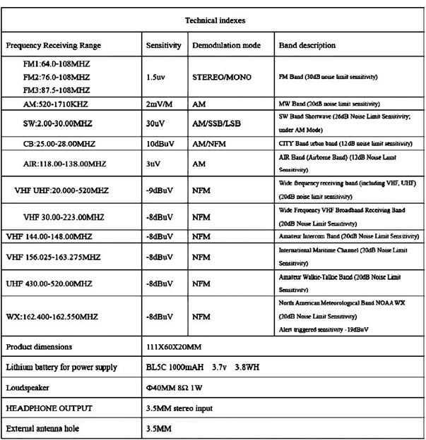

**Cautions**

1. Lower sound, sound distortion and beep all indicate insufficient battery. Please charge the battery in time.
2. Please do not exert heavy pressure, strong or violent impact.
3. Do not put the machine in direct sunlight, high temperature, wet place and do not use it in environment below -5°C or higher than +50°C.
4. Do not use chemical reagents to wipe the casing so as to protect the casing surface.
5. Do not disassemble the machine or adjust parameters of internal components.
6. Obvious man-made damages (antenna fracture, bending, falling off, battery leakage corrosion) are not covered by the warranty.
7. We do not provide free warranty for accessories such as outer shell, external antenna, chassis, battery, headset and cable.